Technical Architecture

Team Lead 1: N.Bala Kumar

Team Member 2: K.M.Guruprasath

Team Member 3: V.Guhan

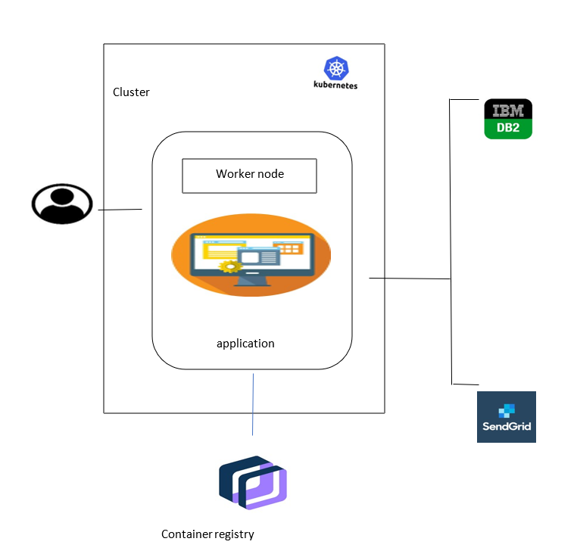

**SOFTWARES USED IN TECHNICAL ARCHITECTURE AND ITS PURPOSE:**

**Kubernetes cluster:**

A Kubernetes cluster is a set of nodes that run containerized applications. Containerizing applications packages an app with its dependences and some necessary services. They are more lightweight and flexible than virtual machines.

**Container Registry:**

Container Registry is a single place for your team to manage Docker images, perform vulnerability analysis, and decide who can access what with fine-grained access control. Existing CI/CD integrations let you set up fully automated Docker pipelines to get fast feedback.

**IBM DB2:**

Db2, or Database 2, is a set of relational database products built and offered by IBM.DB2 is designed to store, analyze and retrieve the data efficiently. In this project, it stores the customers data.

**Sendgrid:**

SendGrid is a cloud-based SMTP provider that allows you to send email without having to maintain email servers. SendGrid manages all of the technical details, from scaling the infrastructure to ISP outreach and reputation monitoring to whitelist services and real time analytics. It is a cloud-based email marketing tool that assists marketers and developers with campaign management and audience engagement. In this project , it sends the email alert if there is no stock.